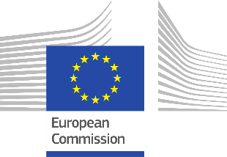

Second online workshop
Business to Government (B2G) data sharing in cities
‘Towards green, smart and affordable mobility services in cities and communities’
May 2021
10.00-11.30

Agenda:
- Welcome and introduction by moderator – Federica Bordelot, policy advisor, Eurocities (10 mins.)

- Towards green, smart and affordable mobility services in cities and communities: lessons learned from B2G mobility data sharing

  - Use case from city of Barcelona (15 mins)
  - Use case from city of Venice, managing authority, (15 mins)
  - Use case from city of Dublin (tbc) (15 mins)

- Q&A (30 mins)

- Conclusion and next steps (5 mins.)

